Large Data Set

Years included:

__________ & __________

Months included:

____________ to ______________

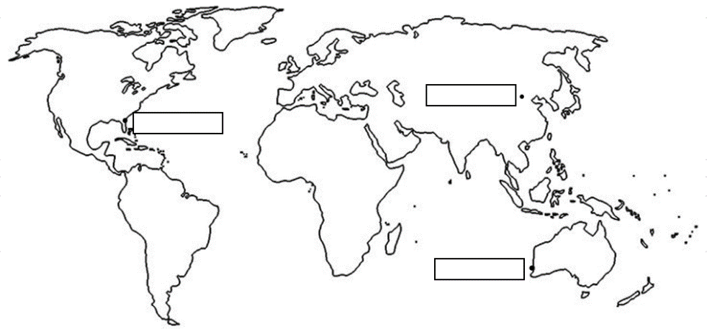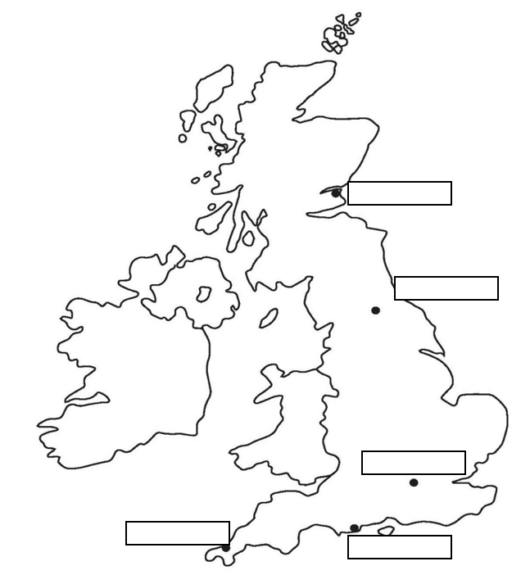

Months included with 30 days:

|  |  |  |
| --- | --- | --- |
| **Cities included** | 3. Heathrow | 6.Leeming |
| 1. Beijing | 4. Hurn | 7. Leuchars |
| 1. Camborne | 5. Jacksonville | 8. Perth |

Data recorded

|  |  |  |  |  |  |  |
| --- | --- | --- | --- | --- | --- | --- |
| Daily Mean Temperature | Units and accuracy | n/a means | | Range of times covered | | Range of temperatures |
| Daily Total Rainfall | Units and accuracy  What does tr mean? | | Max rainfall UK/worldwide | | Range of times covered | |
| Daily Total Sunshine | Units and accuracy (how is it measured) | | | Max/min | | |
| Daily Maximum Relative Humidity | What is it? | | | How is it measured? | | |
| Wind | What is measured and how (4 types)? | | How are they measured? | | Max/min UK/worldwide | |
| Visibility | What is it? | | | How is it measured? | | |
| Pressure | How is it measured? | | | Max/min | | |
| Daily mean total cloud | What is it? | | | What units are used to measure it? | | |

Daily Mean Temperature

|  |  |  |
| --- | --- | --- |
| Which months have the highest average temperature in the UK? | Which locations are warmest in the UK? | Which locations are coldest in the UK? |
| Which locations are warmer worldwide? | Which locations are colder worldwide? | Are there any cities that have very different weather to the others? |
| What range of temperatures do you get in the UK? Worldwide? | Is there a difference between 1987 average temperatures and 2015? |  |

Daily Total Rainfall

|  |  |  |
| --- | --- | --- |
| Which months are wettest for UK cities? | Is there a difference in rainfall between 1987 and 2015 | Do all cities follow a similar pattern for rainfall? Are there any with very different patterns? |
| Which of the cities is the wettest in the UK? What about worldwide? | Which of the cities is the driest in the UK? What about worldwide? |  |

Windspeed

|  |  |  |
| --- | --- | --- |
| Typical average windspeed | Windiest months UK? Any difference with worldwide cities? | Any differences between 1987 and 2015? |