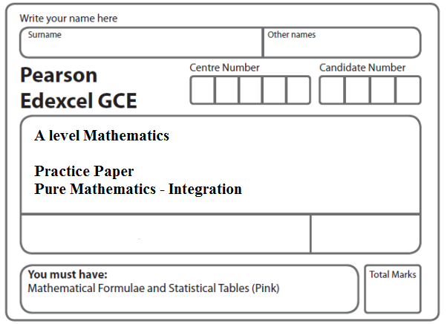
Instructions
- Use black ink or ball-point pen.
- If pencil is used for diagrams/sketches/graphs it must be dark (HB or B).
- Fill in the boxes at the top of this page with your name, centre number and candidate number.
- Answer all the questions and ensure that your answers to parts of questions are clearly labelled.
- Answer the questions in the spaces provided – there may be more space than you need.
- You should show sufficient working to make your methods clear. Answers without working may not gain full credit.
- Inexact answers should be given to three significant figures unless otherwise stated.
Information
- A booklet ‘Mathematical Formulae and Statistical Tables’ is provided.
- There are 12 questions in this question paper. The total mark for this paper is 119.
- The marks for each question are shown in brackets – use this as a guide as to how much time to spend on each question.
- Calculators must not be used for questions marked with a * sign.
Advice
• Read each question carefully before you start to answer it.
• Try to answer every question.
• Check your answers if you have time at the end.
• If you change your mind about an answer, cross it out and put your new answer and any working underneath.
1. f(x) = = + + .
(a) Find the values of the constants A, B and C.
(4)
(b) (i) Hence find .
(ii) Find , leaving your answer in the form a + ln b, where a and b are constants.
(6)
(Total 10 marks)
___________________________________________________________________________

2. Use integration to find the exact value of.
(Total 6 marks)
___________________________________________________________________________

3. (a) Use integration to find
.
(5)
(b) Hence calculate
.
(2)
(Total 7 marks)
___________________________________________________________________________

4. (a) Use integration by parts to find
(3)
(b) Using your answer to part (a), find
(3)
(Total 6 marks)
___________________________________________________________________________
5.

Figure 1

Figure 1 shows a sketch of part of the curve with equation y = 4x − , x ≥ 0.

The curve meets the x-axis at the origin O and cuts the x-axis at the point A.

(a) Find, in terms of ln 2, the x coordinate of the point A.
(2)
(b) Find .
(3)

The finite region R, shown shaded in Figure 1, is bounded by the x-axis and the curve with equation y = 4x − , x ≥ 0.

(c) Find, by integration, the exact value for the area of R.
Give your answer in terms of ln 2.
(3)
(Total 8 marks)
___________________________________________________________________________
6.
Figure 2
Figure 2 shows the finite region R bounded by the x-axis, the y-axis, the line x = and the curve with equation
y = , 0 ≤ x ≤

The table shows corresponding values of x and y for y = .

x | 0
y | 1 | 1.035276 |  | 1.414214

(a) Complete the table above giving the missing value of y to 6 decimal places.
(1)
(b) Using the trapezium rule, with all of the values of y from the completed table, find an approximation for the area of R, giving your answer to 4 decimal places.
(3)

Region R is rotated through 2π radians about the x-axis.

(c) Use calculus to find the exact volume of the solid formed.
(4)
(Total 8 marks)
___________________________________________________________________________

7. (a) Express in partial fractions.
(3)
(b) Hence find , where x > 1.
(3)
(c) Find the particular solution of the differential equation

(x – 1)(3x + 2) = 5y, x > 1,

for which y = 8 at x = 2 . Give your answer in the form y = f(x).
(6)
(Total 12 marks)
___________________________________________________________________________

8. (i) Given that y > 0, find
.
(6)
(ii) (a) Use the substitution x = 4sin²θ to show that

= λ,

where λ is a constant to be determined.
(5)
(b) Hence use integration to find

,

giving your answer in the form aπ + b, where a and b are exact constants.
(4)
(Total 15 marks)
___________________________________________________________________________

9.

Figure 3

Figure 3 shows a sketch of part of the curve C with parametric equations

x = 1 – t, y = 2^{t} – 1.

The curve crosses the y-axis at the point A and crosses the x-axis at the point B.

(a) Show that A has coordinates (0, 3).
(2)
(b) Find the x-coordinate of the point B.
(2)
(c) Find an equation of the normal to C at the point A.
(5)

The region R, as shown shaded in Figure 3, is bounded by the curve C, the line x = –1 and the x-axis.

(d) Use integration to find the exact area of R.
(6)
(Total 15 marks)
___________________________________________________________________________
10.

Figure 4

Figure 4 shows a sketch of the curve with equation y =, 0 ≤ x ≤ 3.

The finite region R, shown shaded in Figure 4, is bounded by the curve, the x-axis, and the y-axis.

(a) Use the substitution x = 1 + 2 sin θ to show that

= ,
where k is a constant to be determined.
(5)
(b) Hence find, by integration, the exact area of R.
(3)
(Total 8 marks)
___________________________________________________________________________

11.

Figure 5

Figure 5 shows a sketch of part of the curve C with parametric equations
x = 3𝜃sin𝜃, y = sec³𝜃, 0 ⩽ 𝜃 <
The point P(k, 8) lies on C, where k is a constant.
(a) Find the exact value of k.
(2)

The finite region R, shown shaded in Figure 5, is bounded by the curve C, the y-axis,
the x-axis and the line with equation x = k.
(b) Show that the area of R can be expressed in the form
where 𝜆, α and β are constants to be determined.
(4)
(c) Hence use integration to find the exact value of the area of R.
(6)
(Total 12 marks)
___________________________________________________________________________

12. a) Express in partial fractions.
(3)

A team of conservationists is studying the population of meerkats on a nature reserve. The population is modelled by the differential equation

= P(5 – P), t ≥ 0,

where P, in thousands, is the population of meerkats and t is the time measured in years since the study began.

Given that when t = 0, P = 1,

(b) solve the differential equation, giving your answer in the form,

P =

where a, b and c are integers.
(8)
(c) Hence show that the population cannot exceed 5000.
(1)
(Total 12 marks)

TOTAL FOR PAPER: 119 MARKS

