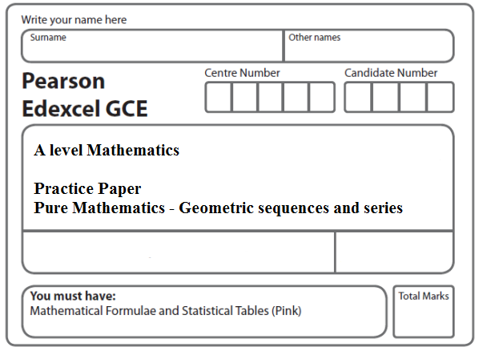
Instructions
- Use black ink or ball-point pen.
- If pencil is used for diagrams/sketches/graphs it must be dark (HB or B).
- Fill in the boxes at the top of this page with your name, centre number and candidate number.
- Answer all the questions and ensure that your answers to parts of questions are clearly labelled.
- Answer the questions in the spaces provided – there may be more space than you need.
- You should show sufficient working to make your methods clear. Answers without working may not gain full credit.
- Inexact answers should be given to three significant figures unless otherwise stated.
Information
- A booklet ‘Mathematical Formulae and Statistical Tables’ is provided.
- There are 8 questions in this question paper. The total mark for this paper is 70.
- The marks for each question are shown in brackets – use this as a guide as to how much time to spend on each question.
- Calculators must not be used for questions marked with a * sign.
Advice
• Read each question carefully before you start to answer it.
• Try to answer every question.
• Check your answers if you have time at the end.
• If you change your mind about an answer, cross it out and put your new answer and any working underneath.
1. A geometric series has first term a and common ratio r = .
The sum of the first 4 terms of this series is 175.

(a) Show that a = 64.
(2)
(b) Find the sum to infinity of the series.
(2)
(c) Find the difference between the 9th and 10th terms of the series.
Give your answer to 3 decimal places.
(3)
(Total 7 marks)
___________________________________________________________________________

2. A geometric series has first term a = 360 and common ratio r = .

Giving your answers to 3 significant figures where appropriate, find

(a) the 20th term of the series,
(2)
(b) the sum of the first 20 terms of the series,
(2)
(c) the sum to infinity of the series.
(2)
(Total 6 marks)
___________________________________________________________________________
3. A geometric series has first term a, where a ≠ 0, and common ratio r.
The sum to infinity of this series is 6 times the first term of the series.

(a) Show that r = .
(2)

Given that the fourth term of this series is 62.5,

(b) find the value of a,
(2)
(c) find the difference between the sum to infinity and the sum of the first 30 terms, giving your answer to 3 significant figures.
(4)
(Total 8 marks)
___________________________________________________________________________

4. A company predicts a yearly profit of £120 000 in the year 2013. The company predicts that the yearly profit will rise each year by 5%. The predicted yearly profit forms a geometric sequence with common ratio 1.05.

(a) Show that the predicted profit in the year 2016 is £138 915.
(1)

(b) Find the first year in which the yearly predicted profit exceeds £200 000.
(5)

(c) Find the total predicted profit for the years 2013 to 2023 inclusive, giving your answer to the nearest pound.
(3)
(Total 9 marks)
___________________________________________________________________________

5. The second and fifth terms of a geometric series are 750 and –6 respectively.

Find

(a) the common ratio of the series,
(3)
(b) the first term of the series,
(2)
(c) the sum to infinity of the series.
(2)
(Total 7 marks)
___________________________________________________________________________

6. The second and third terms of a geometric series are 192 and 144 respectively.

For this series, find

(a) the common ratio,
(2)
(b) the first term,
(2)
(c) the sum to infinity,
(2)
(d) the smallest value of n for which the sum of the first n terms of the series exceeds 1000.
(4)
(Total 10 marks)
___________________________________________________________________________

7. The first three terms of a geometric sequence are
7k – 5, 5k – 7, 2k + 10
where k is a constant.
(a) Show that 11k² – 130k + 99 = 0
(4)

Given that k is not an integer,
(b) show that k =
(2)

For this value of k,
(c) (i) evaluate the fourth term of the sequence, giving your answer as an exact fraction,
(ii) evaluate the sum of the first ten terms of the sequence.
(6)
(Total 12 marks)
___________________________________________________________________________

8. A geometric series is a + ar + ar² + ...

(a) Prove that the sum of the first n terms of this series is given by

S_{n} =
(4)

The third and fifth terms of a geometric series are 5.4 and 1.944 respectively and all the terms in the series are positive.

For this series find,

(b) the common ratio,
(2)
(c) the first term,
(2)
(d) the sum to infinity.
(3)
(Total 11 marks)
___________________________________________________________________________
TOTAL FOR PAPER: 70 MARKS

