**Year 1 Applied Chapter 2: Measures of Spread Exam Questions (50 mins)**

**Q1.**

Keith records the amount of rainfall, in mm, at his school, each day for a week. The results are given below.



Jenny then records the amount of rainfall, *x* mm, at the school each day for the following 21 days. The results for the 21 days are summarised below.



(a) Calculate the mean amount of rainfall during the whole 28 days.

**(2)**

Keith realises that he has transposed two of his figures. The number 9.4 should have been 4.9 and the number 0.5 should have been 5.0. Keith corrects these figures.

(b) State, giving your reason, the effect this will have on the mean.

**(2)**

**(Total 4 marks)**

**Q2.**

The mark, *x*, scored by each student who sat a statistics examination is coded using

*y* = 1.4*x* − 20

The coded marks have mean 60.8 and standard deviation 6.60

Find the mean and the standard deviation of *x*.

**(4)**

**(Total 4 marks)**

**Q3.**

The following table summarises the times, *t* minutes to the nearest minute, recorded for a group of students to complete an exam.

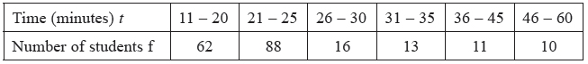

[You may use  f*t*2 = 134281.25]

(a)  Estimate the mean and standard deviation of these data.

**(5)**

(b)  Use linear interpolation to estimate the value of the median.

**(2)**

(c)  Show that the estimated value of the lower quartile is 18.6 to 3 significant figures.

**(1)**

(d)  Estimate the interquartile range of this distribution.

**(2)**

(e)  Give a reason why the mean and standard deviation are not the most appropriate summary statistics to use with these data.

**(1)**

The person timing the exam made an error and each student actually took 5 minutes less than the times recorded above. The table below summarises the actual times.

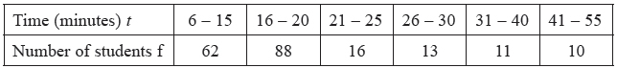

(f)  Without further calculations, explain the effect this would have on each of the estimates found in parts (a), (b), (c) and (d).

**(3)**

**(Total 14 marks)**

**Q4.**

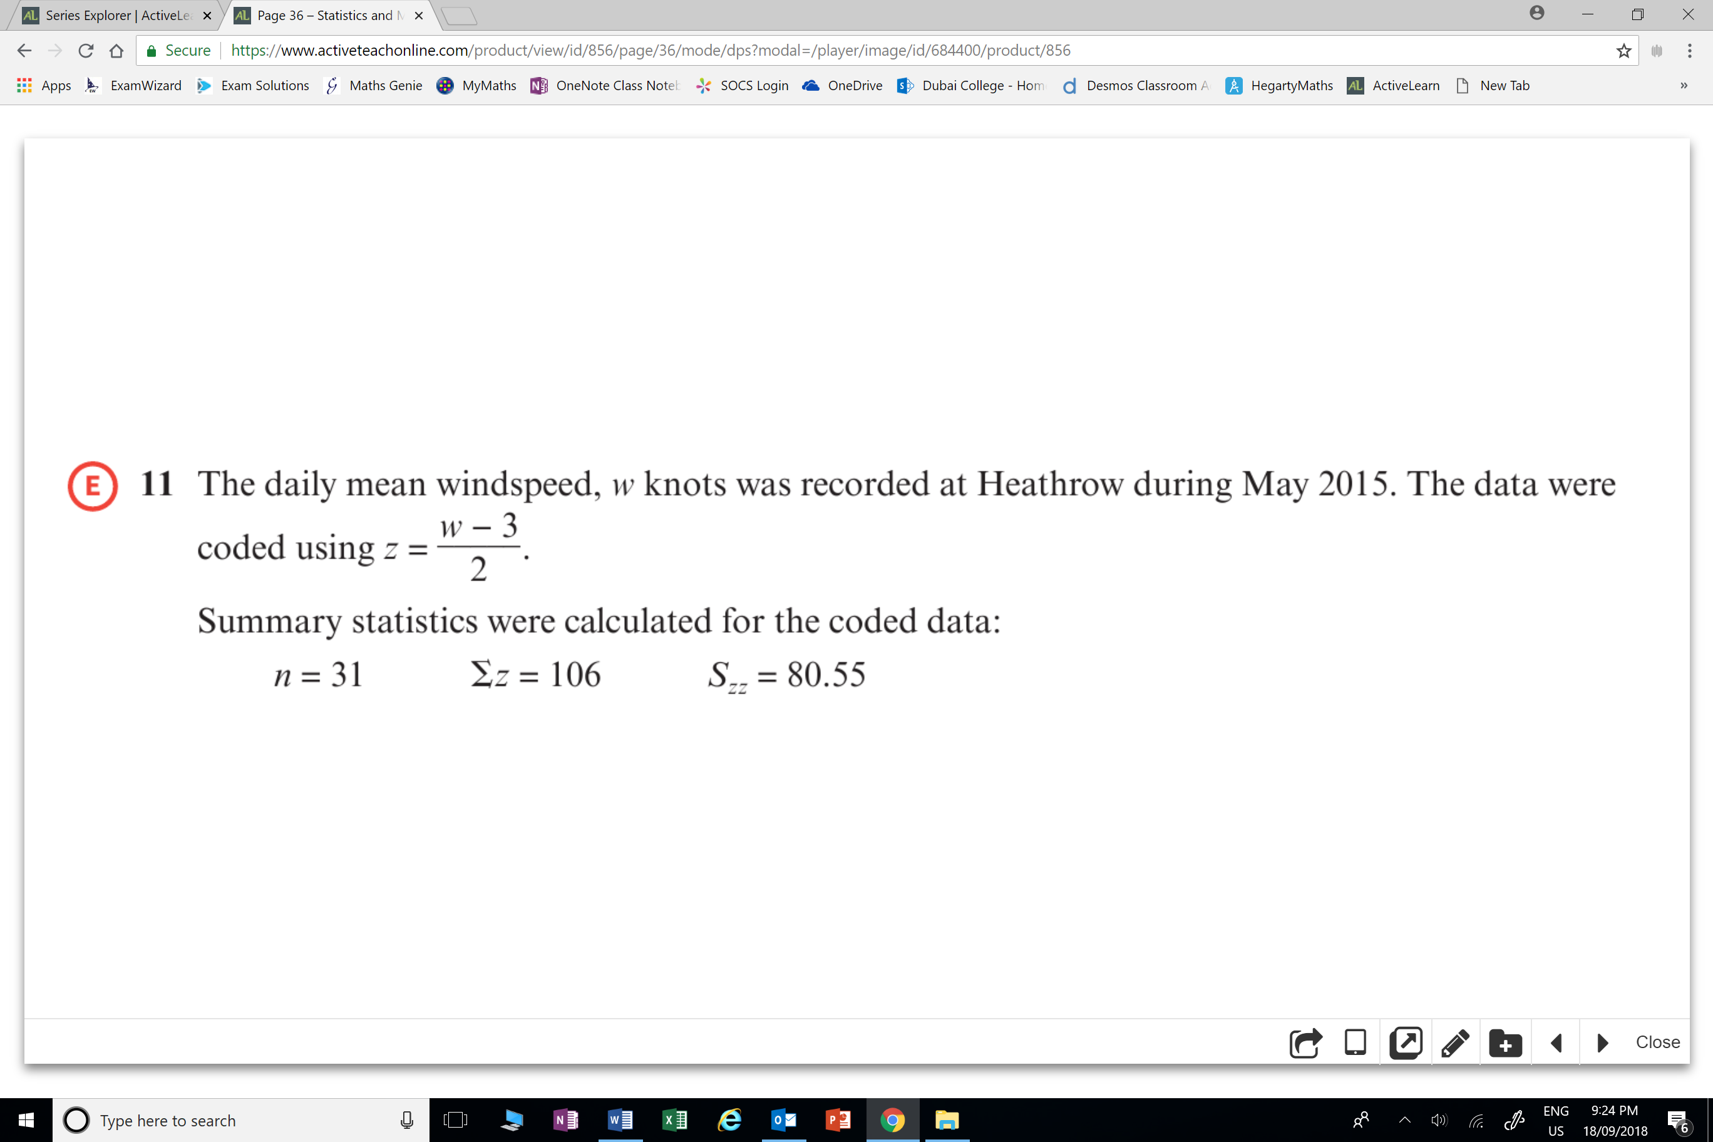

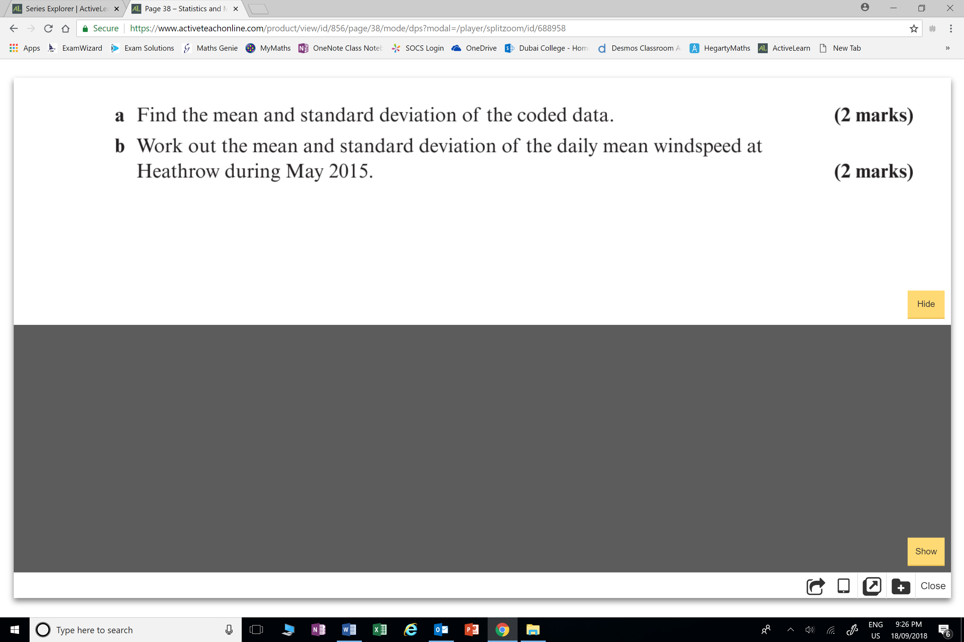

**Q5.**

