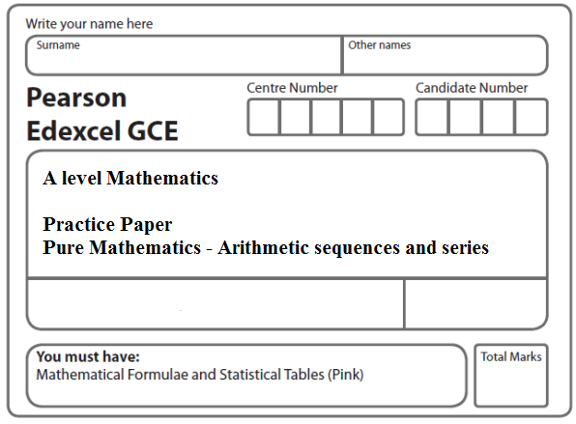
Instructions
- Use black ink or ball-point pen.
- If pencil is used for diagrams/sketches/graphs it must be dark (HB or B).
- Fill in the boxes at the top of this page with your name, centre number and candidate number.
- Answer all the questions and ensure that your answers to parts of questions are clearly labelled.
- Answer the questions in the spaces provided – there may be more space than you need.
- You should show sufficient working to make your methods clear. Answers without working may not gain full credit.
- Inexact answers should be given to three significant figures unless otherwise stated.
Information
- A booklet ‘Mathematical Formulae and Statistical Tables’ is provided.
- There are 10 questions in this question paper. The total mark for this paper is 81.
- The marks for each question are shown in brackets – use this as a guide as to how much time to spend on each question.
- Calculators must not be used for questions marked with a * sign.
Advice
• Read each question carefully before you start to answer it.
• Try to answer every question.
• Check your answers if you have time at the end.
• If you change your mind about an answer, cross it out and put your new answer and any working underneath.
1. A company, which is making 140 bicycles each week, plans to increase its production.
The number of bicycles produced is to be increased by d each week, starting from 140
in week 1, to 140 + d in week 2, to 140 + 2d in week 3 and so on, until the company is
producing 206 in week 12.

(a) Find the value of d.
(2)

After week 12 the company plans to continue making 206 bicycles each week.
(b) Find the total number of bicycles that would be made in the first 52 weeks starting
from and including week 1.
(5)
(Total 7 marks)
___________________________________________________________________________

2. A boy saves some money over a period of 60 weeks. He saves 10p in week 1, 15p in week 2, 20p in week 3 and so on until week 60. His weekly savings form an arithmetic sequence.

(a) Find how much he saves in week 15.
(2)
(b) Calculate the total amount he saves over the 60 week period.
(3)

The boy’s sister also saves some money each week over a period of m weeks. She saves 10p in week 1, 20p in week 2, 30p in week 3 and so on so that her weekly savings form an arithmetic sequence. She saves a total of £63 in the m weeks.

(c) Show that
m(m + 1) = 35 × 36.
(4)
(d) Hence write down the value of m.
(1)
(Total 10 marks)
___________________________________________________________________________

3. An arithmetic sequence has first term a and common difference d. The sum of the first 10 terms of the sequence is 162.

(a) Show that 10a + 45d = 162.
(2)
Given also that the sixth term of the sequence is 17,

(b) write down a second equation in a and d,
(1)
(c) find the value of a and the value of d.
(4)
(Total 7 marks)
___________________________________________________________________________

4. A company, which is making 200 mobile phones each week, plans to increase its production.

The number of mobile phones produced is to be increased by 20 each week from 200 in week 1 to 220 in week 2, to 240 in week 3 and so on, until it is producing 600 in week N.

(a) Find the value of N.
(2)

The company then plans to continue to make 600 mobile phones each week.

(b) Find the total number of mobile phones that will be made in the first 52 weeks starting from and including week 1.
(5)
(Total 7 marks)
___________________________________________________________________________

5. Lewis played a game of space invaders. He scored points for each spaceship that he captured.

Lewis scored 140 points for capturing his first spaceship.

He scored 160 points for capturing his second spaceship, 180 points for capturing his third spaceship, and so on.

The number of points scored for capturing each successive spaceship formed an arithmetic sequence.

(a) Find the number of points that Lewis scored for capturing his 20th spaceship.
(2)

(b) Find the total number of points Lewis scored for capturing his first 20 spaceships.
(3)

Sian played an adventure game. She scored points for each dragon that she captured. The number of points that Sian scored for capturing each successive dragon formed an arithmetic sequence.

Sian captured n dragons and the total number of points that she scored for capturing all n dragons was 8500.

Given that Sian scored 300 points for capturing her first dragon and then 700 points for capturing her nth dragon,

(c) find the value of n.
(3)
(Total 8 marks)
___________________________________________________________________________
6. In the year 2000 a shop sold 150 computers. Each year the shop sold 10 more computers than the year before, so that the shop sold 160 computers in 2001, 170 computers in 2002, and so on forming an arithmetic sequence.

(a) Show that the shop sold 220 computers in 2007.
(2)
(b) Calculate the total number of computers the shop sold from 2000 to 2013 inclusive.
(3)

In the year 2000, the selling price of each computer was £900. The selling price fell by £20 each year, so that in 2001 the selling price was £880, in 2002 the selling price was £860, and so on forming an arithmetic sequence.

(c) In a particular year, the selling price of each computer in £s was equal to three times the number of computers the shop sold in that year. By forming and solving an equation, find the year in which this occurred.
(4)
(Total 9 marks)
___________________________________________________________________________

7. Jess started work 20 years ago. In year 1 her annual salary was £17 000. Her annual salary increased by £1500 each year, so that her annual salary in year 2 was £18 500, in year 3 it was £20 000 and so on, forming an arithmetic sequence. This continued until she reached her maximum annual salary of £32000 in year k. Her annual salary then remained at £32 000.

(a) Find the value of the constant k.
(2)

(b) Calculate the total amount that Jess has earned in the 20 years.
(5)
(Total 7 marks)
___________________________________________________________________________

8. A company offers two salary schemes for a 10-year period, Year 1 to Year 10 inclusive.

Scheme 1: Salary in Year 1 is £P.
Salary increases by £(2T ) each year, forming an arithmetic sequence.

Scheme 2: Salary in Year 1 is £(P + 1800).
Salary increases by £T each year, forming an arithmetic sequence.

(a) Show that the total earned under Salary Scheme 1 for the 10-year period is

£(10P + 90T ).
(2)

For the 10-year period, the total earned is the same for both salary schemes.

(b) Find the value of T.
(4)

For this value of T, the salary in Year 10 under Salary Scheme 2 is £29 850.

(c) Find the value of P.
(3)
(Total 9 marks)
___________________________________________________________________________

9. (a) Calculate the sum of all the even numbers from 2 to 100 inclusive,

2 + 4 + 6 + ...... + 100.
(3)
(b) In the arithmetic series

k + 2k + 3k + ...... + 100,

k is a positive integer and k is a factor of 100.

(i) Find, in terms of k, an expression for the number of terms in this series.

(ii) Show that the sum of this series is
50 + .
(4)
(c) Find, in terms of k, the 50th term of the arithmetic sequence

(2k + 1), (4k + 4), (6k + 7), … ,

giving your answer in its simplest form.
(2)
(Total 9 marks)
___________________________________________________________________________

10. Xin has been given a 14 day training schedule by her coach.

Xin will run for A minutes on day 1, where A is a constant.

She will then increase her running time by (d + 1) minutes each day, where d is a constant.

(a) Show that on day 14, Xin will run for

(A + 13d + 13) minutes.
(2)

Yi has also been given a 14 day training schedule by her coach.

Yi will run for (A – 13) minutes on day 1.

She will then increase her running time by (2d – 1) minutes each day.

Given that Yi and Xin will run for the same length of time on day 14,

(b) find the value of d.
(3)

Given that Xin runs for a total time of 784 minutes over the 14 days,

(c) find the value of A.
(3)
(Total 8 marks)

TOTAL FOR PAPER: 81 MARKS

